PYTHON PROGRAMMING USING SIMPLE

STATEMENTS AND EXPRESSION

1. EXCHANGE THE VALUES OF TWO VARIABLES:

PROGRAM: Method 1

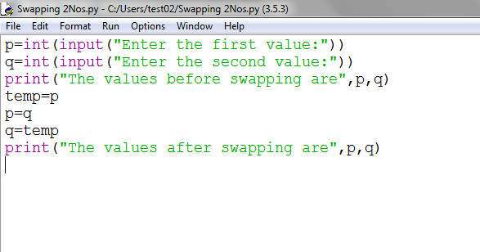

OUTPUT:

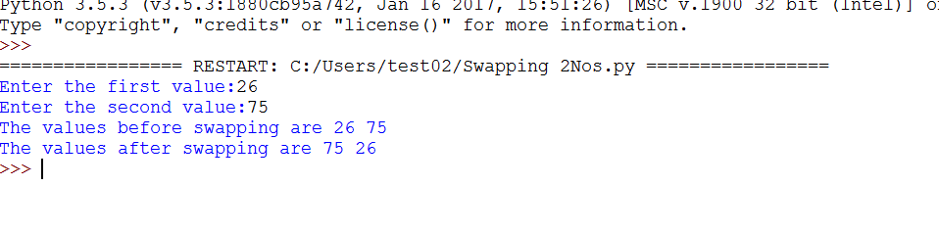

Method 2: [Using comma (,) operator]

Program:

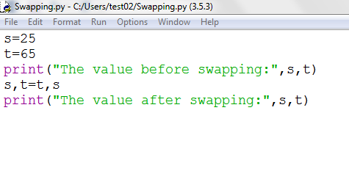

Output:

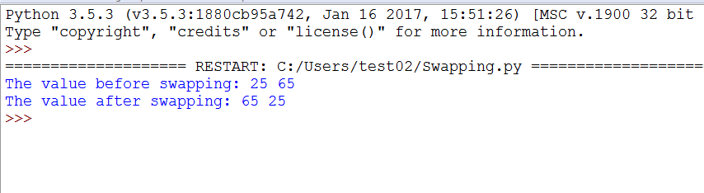

Method 3: [Using Arithmetic Operator]

Program:

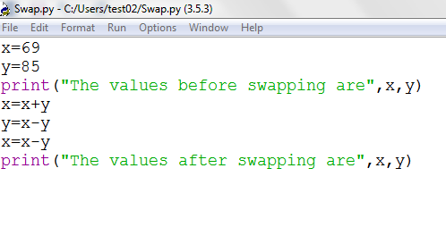

Output:

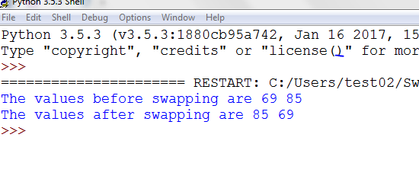

Method 4: [Using XOR gate]

Program:

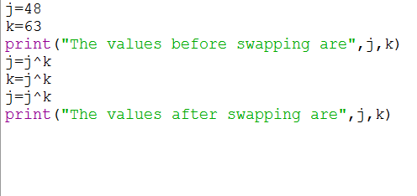

Output:

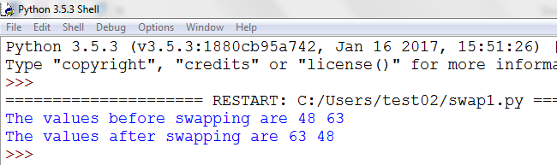

2 CIRCULATE n VARIABLES:

Method1: [Using Inbuilt Function]

Program:

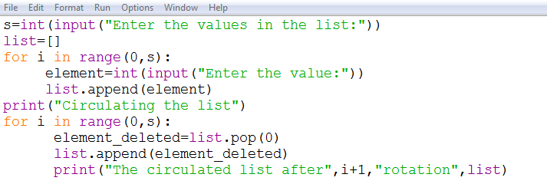

Output:

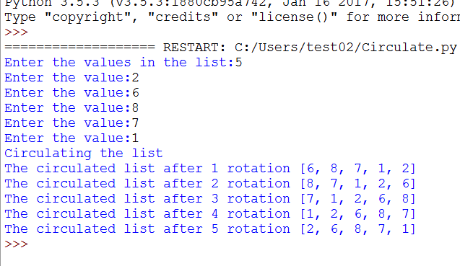

Method 2:

Program:

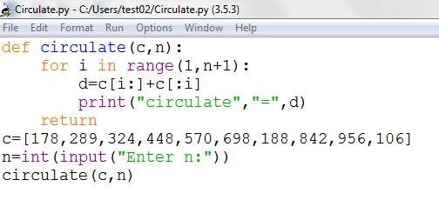

Output:

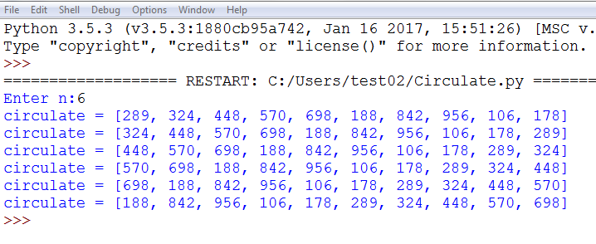

3-DISTANCE BETWEEN TWO POINTS

Program:

O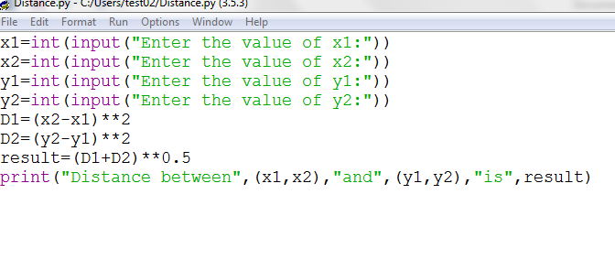

Output:

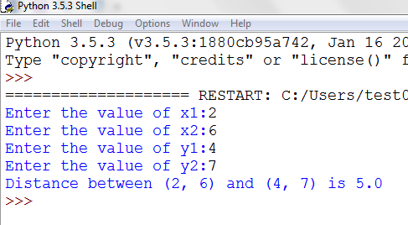

4-FACTORIAL OF A NUMBER

Program:

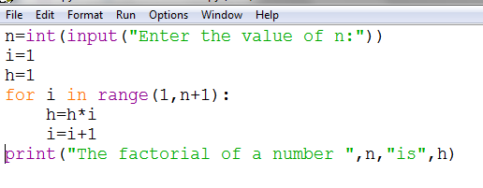

Output:

